**Coding Challenge - Car Rental System – SQL**

Instructions

• Coding Challenge submissions should be done through the partcipants’ Github repository, and

the link should be shared with trainers and Hexavarsity.

SQL Schema:

1. Vehicle Table:

• vehicleID (Primary Key)

• make

• model

• year

• dailyRate

• status (available, notAvailable)

• passengerCapacity

• engineCapacity

2. Customer Table:

• customerID (Primary Key)

• firstName

• lastName

• email

• phoneNumber

3. Lease Table:

• leaseID (Primary Key)

• vehicleID (Foreign Key referencing Vehicle Table)

• customerID (Foreign Key referencing Customer Table)

• startDate

• endDate

• type (to distinguish between DailyLease and MonthlyLease)

4. Payment Table:

• paymentID (Primary Key)

• leaseID (Foreign Key referencing Lease Table)

• paymentDate

• amount

Vehicle Table

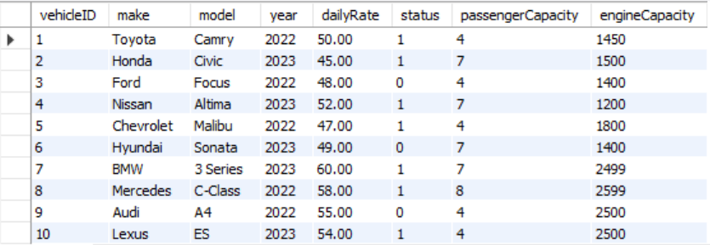

Customer Table

Lease Table

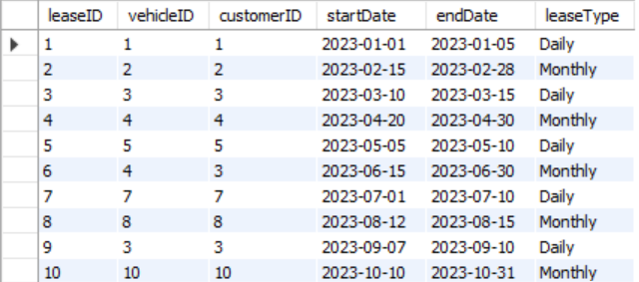

Payment Table

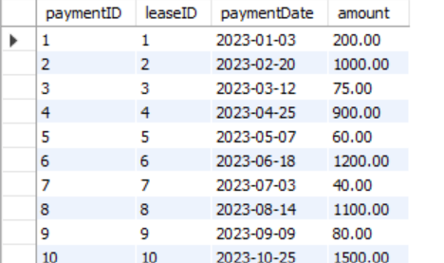

1. Update the daily rate for a Mercedes car to 68.

ANS:

UPDATE Vehicle

SET dailyRate = 68.00

WHERE make = 'Mercedes';

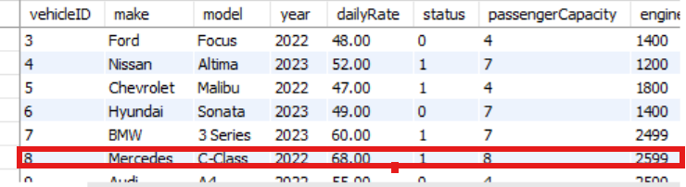

1. Delete a specific customer and all associated leases and payments.

ANS: DELETE FROM Payment

WHERE leaseID IN (SELECT leaseID FROM Lease WHERE customerID = 3);

DELETE FROM Lease

WHERE customerID = 3;

DELETE FROM Customer

WHERE customerID = 3;

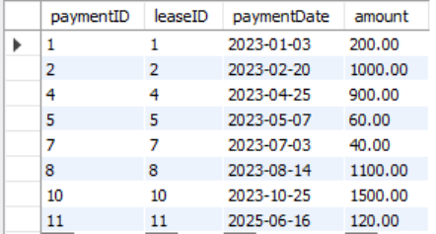

1. Rename the "paymentDate" column in the Payment table to "transactionDate".

ANS: ALTER TABLE Payment

CHANGE COLUMN paymentDate transactionDate DATE;

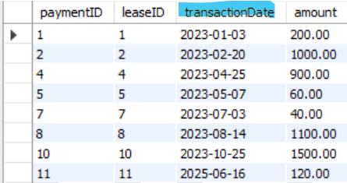

1. Find a specific customer by email.

ANS: SELECT * FROM Customer

WHERE email = 'johndoe@example.com';

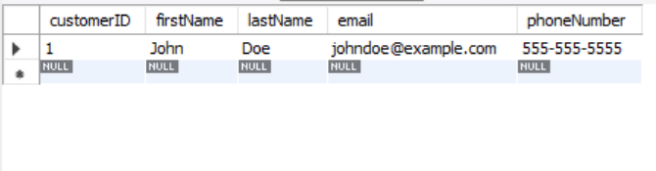

1. Get active leases for a specific customer.

ANS: SELECT * FROM Lease

WHERE endDate >= CURRENT_DATE();

1. Find all payments made by a customer with a specific phone number.

ANS: SELECT

Payment.paymentID,

Payment.leaseID,

Payment.transactionDate,

Payment.amount

FROM Payment

JOIN Lease ON Payment.leaseID = Lease.leaseID

JOIN Customer ON Lease.customerID = Customer.customerID

WHERE Customer.phoneNumber = '555-123-4567';

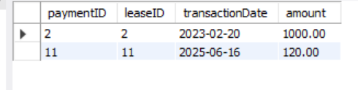

1. Calculate the average daily rate of all available cars.

ANS: SELECT AVG(dailyRate) AS averageAvailableRate

FROM Vehicle

WHERE status = 1;

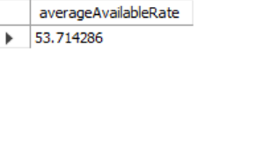

1. Find the car with the highest daily rate.

ANS: SELECT *

FROM Vehicle

ORDER BY dailyRate DESC

LIMIT 1;

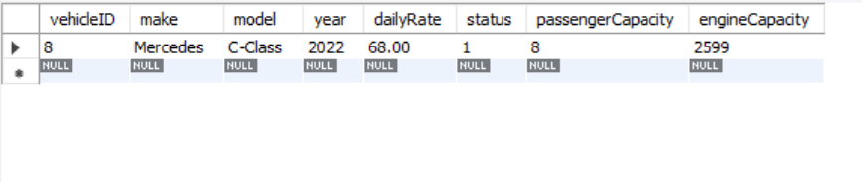

1. Retrieve all cars leased by a specific customer.

ANS: SELECT Vehicle.vehicleID, Vehicle.make, Vehicle.model, Vehicle.year,

Vehicle.dailyRate, Vehicle.status, Vehicle.passengerCapacity, Vehicle.engineCapacity

FROM Vehicle

JOIN Lease ON Vehicle.vehicleID = Lease.vehicleID

WHERE Lease.customerID = 2;

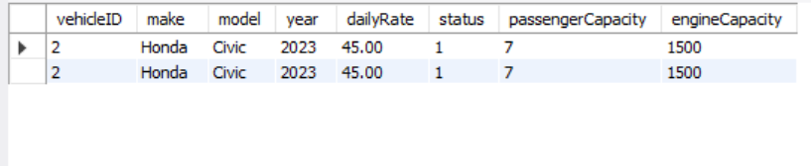

1. Find the details of the most recent lease.

ANS: SELECT *

FROM Lease

ORDER BY endDate DESC

LIMIT 1;

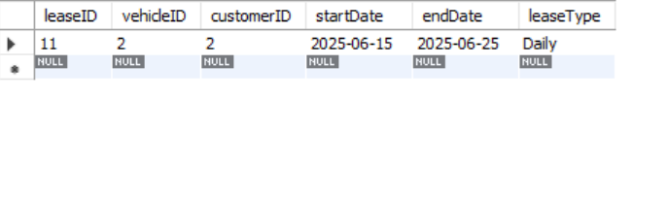

1. List all payments made in the year 2023.

ANS: SELECT *

FROM Payment

WHERE YEAR(transactionDate) = 2023;

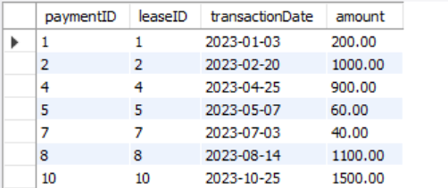

1. Retrieve customers who have not made any payments.

ANS: SELECT DISTINCT Customer.customerID, Customer.firstName, Customer.lastName,

Customer.email, Customer.phoneNumber

FROM Customer

LEFT JOIN Lease ON Customer.customerID = Lease.customerID

LEFT JOIN Payment ON Lease.leaseID = Payment.leaseID

WHERE Payment.paymentID IS NULL;

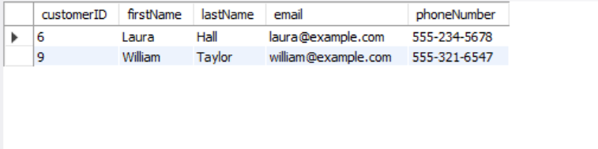

1. Retrieve Car Details and Their Total Payments.

ANS: SELECT V.make, V.model, SUM(P.amount) AS totalPayment

FROM Vehicle V

JOIN Lease L ON V.vehicleID = L.vehicleID

JOIN Payment P ON L.leaseID = P.leaseID

GROUP BY V.vehicleID;

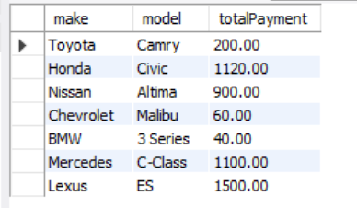

1. Calculate Total Payments for Each Customer.

ANS: SELECT C.customerID, C.firstName, C.lastName, SUM(P.amount) AS totalPaid

FROM Customer C

JOIN Lease L ON C.customerID = L.customerID

JOIN Payment P ON L.leaseID = P.leaseID

GROUP BY C.customerID;

1. List Car Details for Each Lease.

ANS: SELECT L.leaseID, V.make, V.model, L.startDate, L.endDate, L.leaseType

FROM Lease L

JOIN Vehicle V ON L.vehicleID = V.vehicleID;

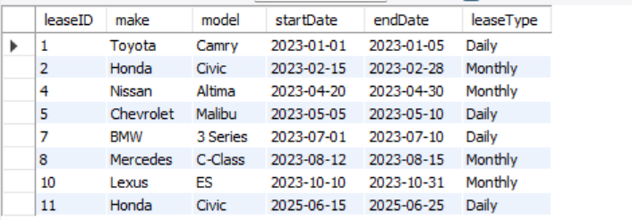

1. Retrieve Details of Active Leases with Customer and Car Information.

ANS: SELECT L.leaseID, C.firstName, C.lastName, V.make, V.model, L.startDate, L.endDate

FROM Lease L

JOIN Customer C ON L.customerID = C.customerID

JOIN Vehicle V ON L.vehicleID = V.vehicleID

WHERE L.endDate >= CURRENT_DATE();

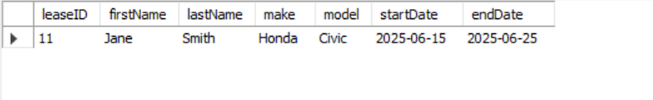

1. Find the Customer Who Has Spent the Most on Leases.

ANS: SELECT C.customerID, C.firstName, C.lastName, SUM(P.amount) AS totalSpent

FROM Customer C

JOIN Lease L ON C.customerID = L.customerID

JOIN Payment P ON L.leaseID = P.leaseID

GROUP BY C.customerID

ORDER BY totalSpent DESC

LIMIT 1;

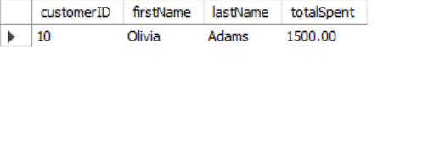

1. List All Cars with Their Current Lease Information.

ANS: SELECT V.vehicleID, V.make, V.model, L.leaseID, L.customerID, L.startDate, L.endDate

FROM Vehicle V

LEFT JOIN Lease L ON V.vehicleID = L.vehicleID

ORDER BY V.vehicleID;

